**Code Enforcement Mission Statement:**

The mission of Hooks Code Enforcement is to provide residents with the highest quality of service while upholding and enforcing codes and standards designed to protect the public's health, safety, and welfare. Our priorities align with established standards, and we are committed to courtesy and professionalism. These principles guide the actions of the Code Enforcement Officer, ensuring that our efforts to combat blight within the City of Hooks are balanced with sensitivity and reason. Code enforcement operates on two fronts: reactive and proactive. Reactive enforcement responds to complaints, whereas proactive enforcement serves as an educational tool. Through proactive measures, we aim to inform the public about existing ordinances and commonly violated regulations. The city actively engages in proactive enforcement to resolve issues without resorting to punitive actions. Throughout all code enforcement interactions, the city strives to educate the public about our codes and ordinances, encouraging voluntary compliance. While many code enforcement cases conclude with voluntary compliance, some situations may deviate from the standard process due to unique circumstances. In such cases, staff may skip certain steps in the code enforcement process to achieve swift compliance. Our primary goal is to educate the community about issues such as tall grass or weeds, junk vehicles, and trash or rubbish violations. We want residents to understand how complaints regarding these matters are handled and the steps we take to ensure compliance.

The general process of how a complaint is handled once received by our office,

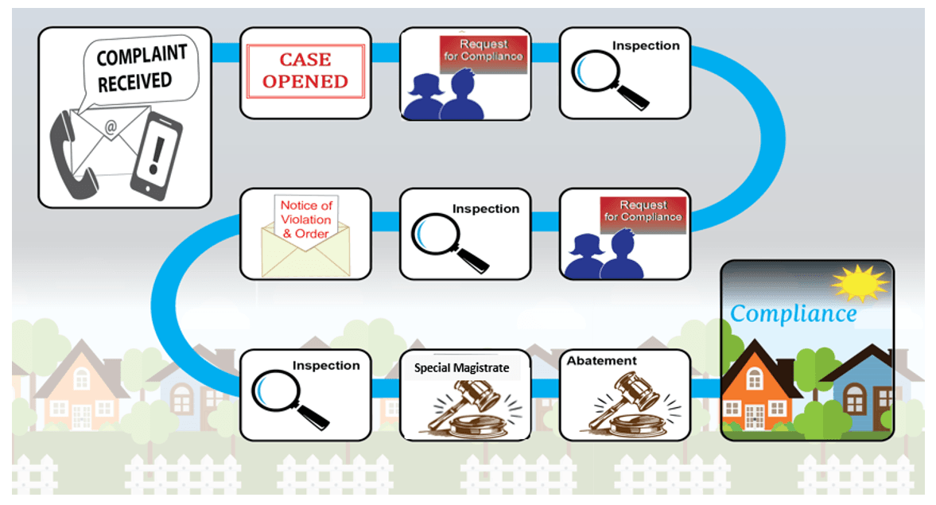

Though the City of Hooks has many codes and ordinances, some occur more frequently than others. The following is a guide to the codes and ordinances most frequently noticed or documented within the city.

**Common Code Violations**

Junk Vehicles Chapter 90

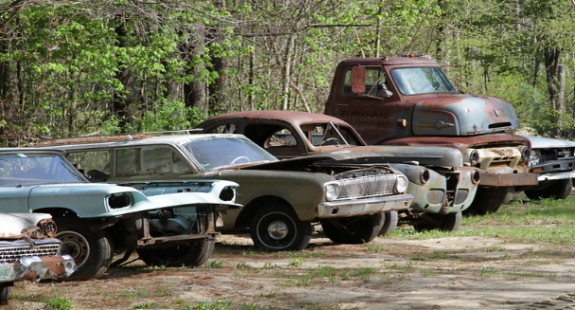

Grass/weeds Chapter 92.04

Trash on property Chapter 92.11

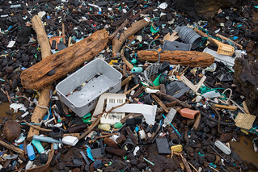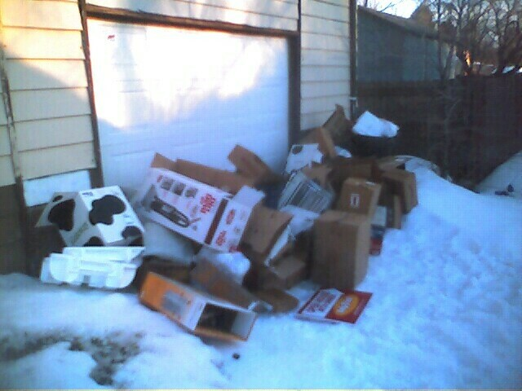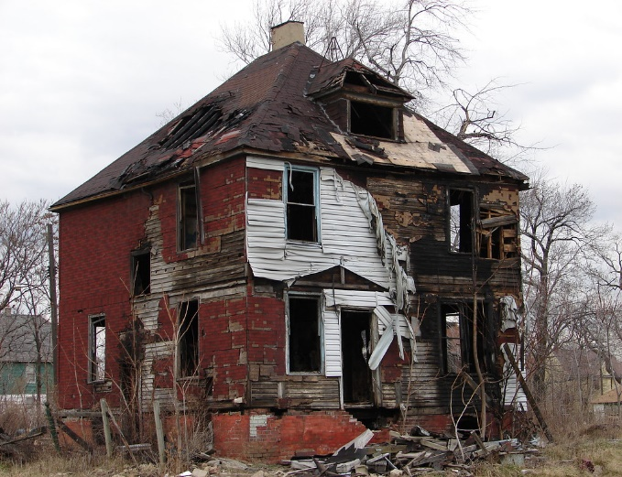

Abandoned Burnt Houses Chapter 92

Frequently asked questions,

* How many days do I usually have to correct an issue? ***Answer = 10 days.***
* How much are the fines if I fail to address the issue? ***Answer = $331.00 per day (Section 10.99 – General Penalty “Each day any violation of any provision of this code or of any ordinance shall continue they shall constitute a separate offense.”***
* Do I have an opportunity to appeal the citation? ***Answer = Yes, within 10 days of receiving the citation. The appeal must be in writing and will be heard at the next available public court session.***
* If I believe I may be in violation of any city ordinance, can I contact the Hooks Police Department for a voluntary inspection without being fined? ***Answer = Yes, a courtesy inspection can be completed with agreed-upon deadlines for correcting the issue without any citations being issued.***
* Where can I find the city ordinances for Hooks? ***Answer = On our city website.***
* Can I make an anonymous complaint? ***Answer = Yes.***
* Are there other ordinances that address noise, offensive odors, and dog barking and howling? ***Answer = Yes****.*